**Initial Design Outline**

**For**

**Unigogo System**

**Version 1.0**

**Prepare by Group 02**

**CSE Department, CUHK**

**WU Bowen (1155091986)**

**LI Jiaxin (1155092037)**

**JIANG Yitong (1155092010)**

**YANG Jiayuan (1155076802)**

**HAN Tianyang (1155091993)**

**February 23, 2018**

1. **Introduction**

**1.1 Project Overview**

Unigogo is an online information sharing system designed to solve the problem of inefficient communication between universities and students/parents. It collects and organizes information and presents neat results according to users’ need, saving them from dull information mining. Besides, it provides a platform where students could share their experiences and get first hand information. Unigogo is powerful and considerate in providing sufficient information when users are choosing universities.

**1.2 Objective**

Unigogo is aimed at helping students to learn the features of different universities in various aspects. Not the same as the official websites of the universities, Unigogo constructs a friendly environment for customers to interact with each other. It provides customers first-hand information posted by the students of the universities and the platform to communicate with the bloggers instantly, which can improve the insight of customers toward the universities and help them to make better and more rational choices.

**1.3 Expected Customers and Market**

Our Web Application, Unigogo, is aimed at serving people around the world who are interested in higher education. The main target market is young people aged from 18 to 30, well-educated, willing to make friends with other students and pursue a promising academic career. Potential customer groups will be students, universities and anyone who are urgent for obtaining information of universities.

Unigogo gives students and pre-students a chance to share their academic experience and campus life, helping them acquire practical information and suggestions. It also acts as a platform for universities to release official announcement and organize activities. Unigogo could offer them statistics for analysis and decision-making.

For the salariat who are not so familiar with universities but still want to receive higher education, Unigogo is an instructive and informative website that can guide them and give them best advice.

**1.4 System Features**

The Unigogo System helps build communities sharing university information. Students and parents could have easy access to various first-hand information from university students. Besides, the system collects and sorts out all kinds of university rankings, providing users with a neat and powerful conditional ranking. For universities, the system functions as an efficient communication channel, where they can release official information and answer user’s questions.

1. **Background**

Our initial idea is rooted in the real needs of a university student. Surveying on the existed education websites, rarely can we find one that centrally provides detailed information of universities all around the world. However, students are desperate to acquire the first-hand information of the target school, like the real school life, accommodation conditions, courses taking and so on. Oftentimes, students need to browse the whole Internet only to find few scattered pieces of information, which is extremely inefficient. To fix the searching inefficiency and information scarcity, we want to create a web application that offers a broad and integrated education platform to facilitate students over the world to post information, retrieve information, communicate with helpful person, plan for the academic future and so on. The core idea is to build a glossary of universities forums in which students can easily get abundant information and instantaneously communicate with students in the interested school. Basically, all the information on the website are provided by students, the user can select the interested university and read the most relevant post or prompt a question. Upon having further personal questions, the user can immediately contact the author of the post via the online chat box.

Three attractive features are included in our design. Firstly, user can easily find the interested school by the search engine at the front page and be navigated to the forum of that school, where plentiful resources are available. Without wasting time browsing the whole Internet, users can find whatever they expect within our website. Secondly, the website encourages interaction among users by enabling users to chat online and following each other. Without any barrier of communication, users can exchange information directly on the website. Last but not the least, the personal front page is powerful. The user can find all the posts he/she once viewed or followed. He/she can also manage relationships between users. Also, he/she can lock up some part of the personal front page for privacy. With various functionalities compacted in our website, the user can easily deal with anything concerning university information.

1. **Specification**

We use three levels of data flow diagrams to specify how our system functions.

**3.1 Level 0**

Level 0 diagram (figure 1) depicts the overall design of our product, which contains the internal system and three external entities, namely users, the administrators and universities.

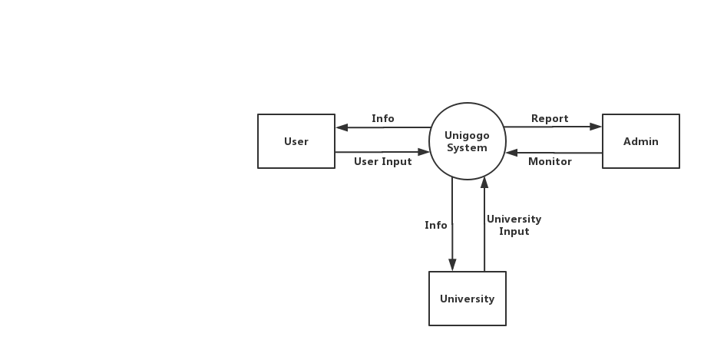

figure 1

**3.2 Level 1**

Level 1 diagram (figure 2) shows a decomposition of the internal system into seven functions. Each function will be further specified in each individual Level 2 diagrams.

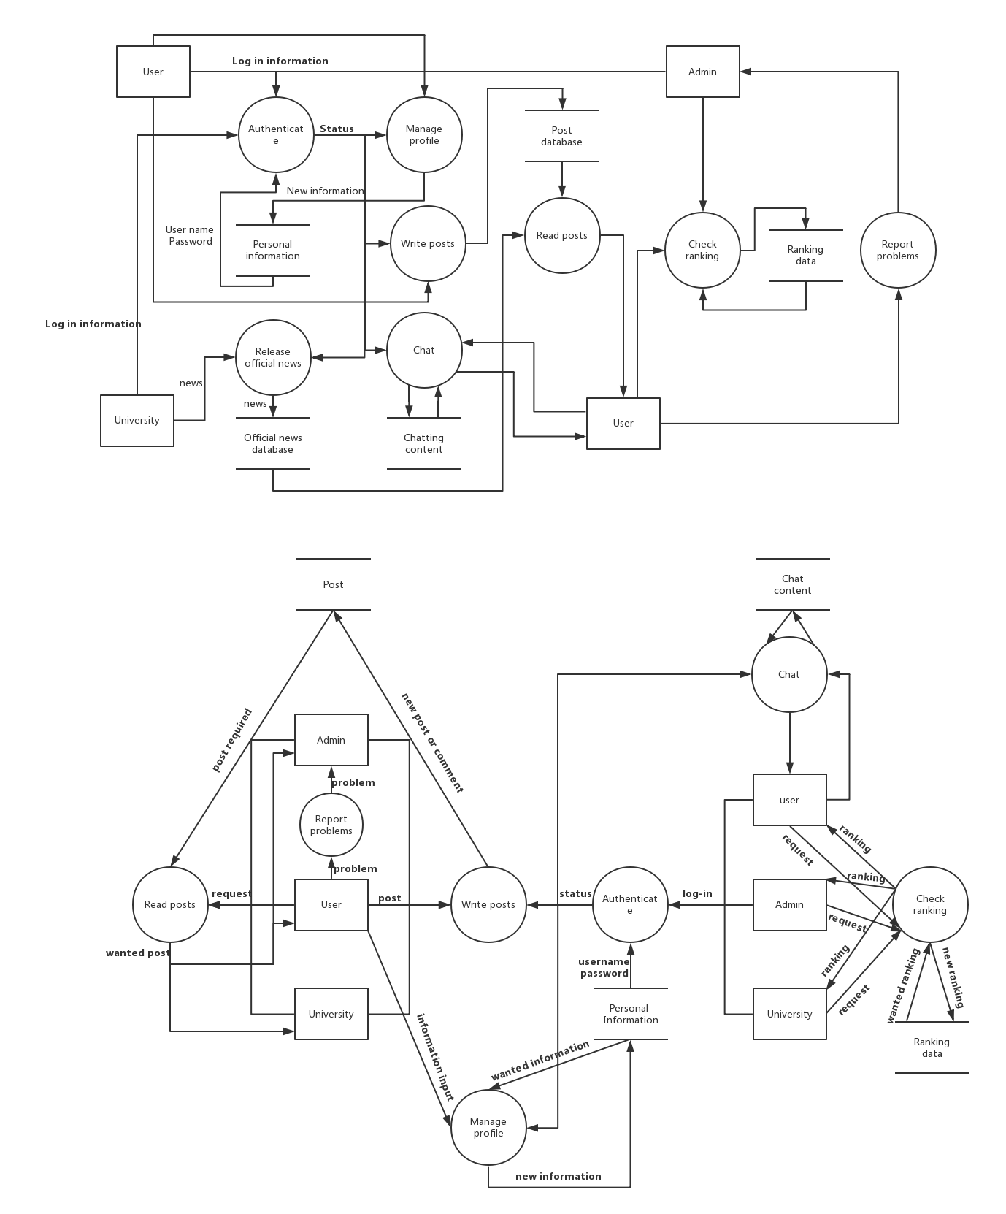

figure 2

**3.3 Level 2**

Level 2 diagrams specify each function in details. For specific descriptions, please refer to 4.2.2 Back-end components.

**3.3.1 Authentication** (figure 3)

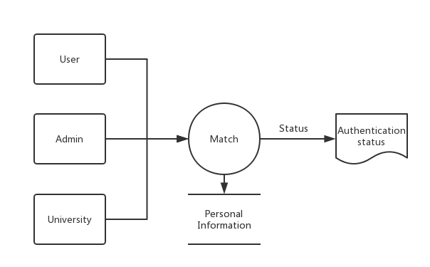

figure 3

**3.3.2 Personal Information Management** (figure 4)

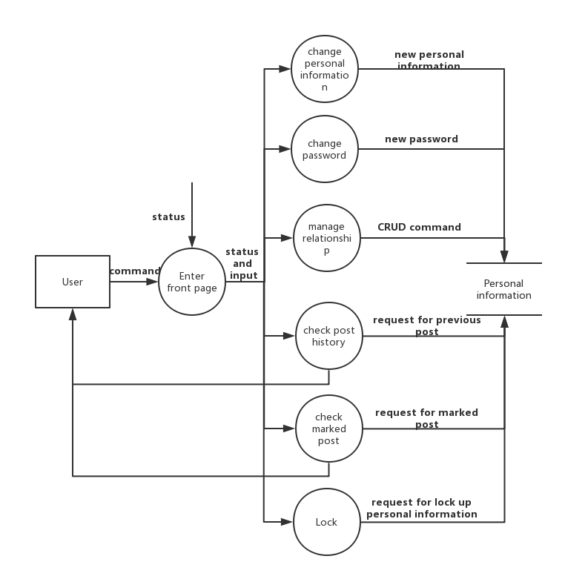

figure 4

**3.3.3 Write Posts** (figure 5)

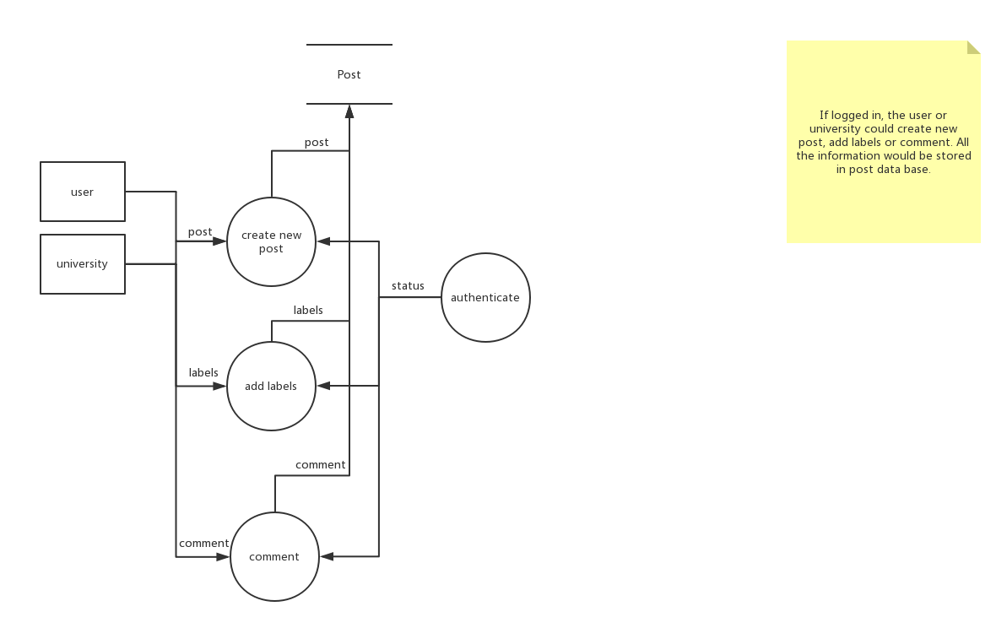

figure 5

**3.3.4 Read Posts** (figure 6)

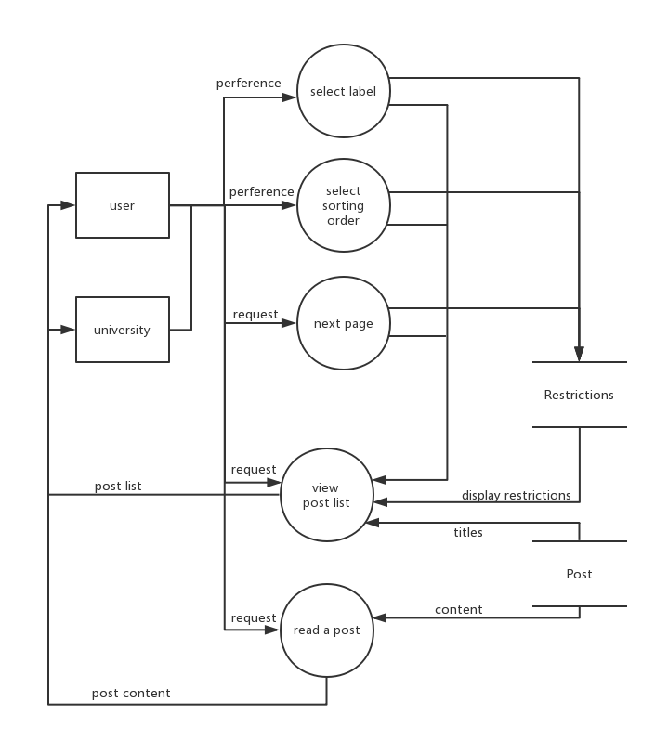

figure 6

**3.3.5 Chat** (figure 7)

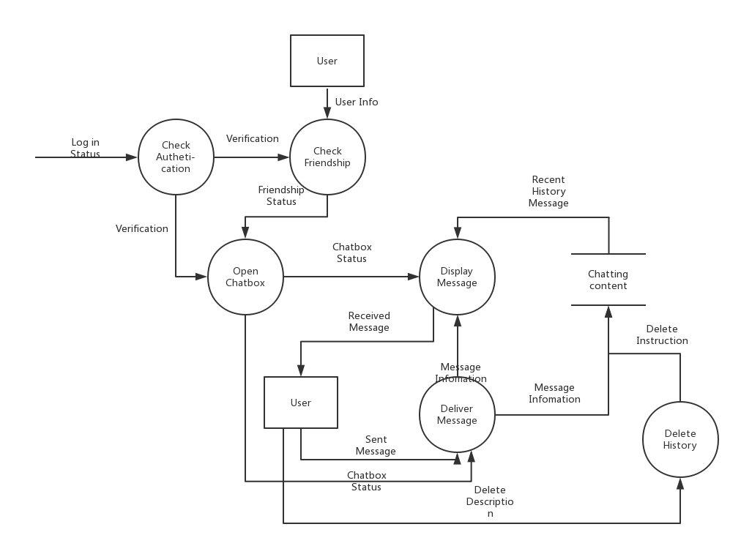

figure 7

**3.3.6 Rank** (figure 8)

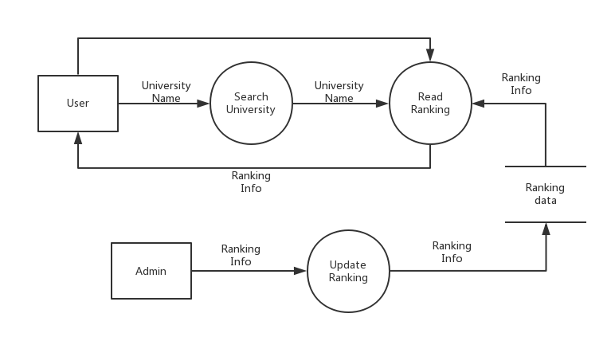

figure 8

**3.3.7 Report Problems** (figure 9)

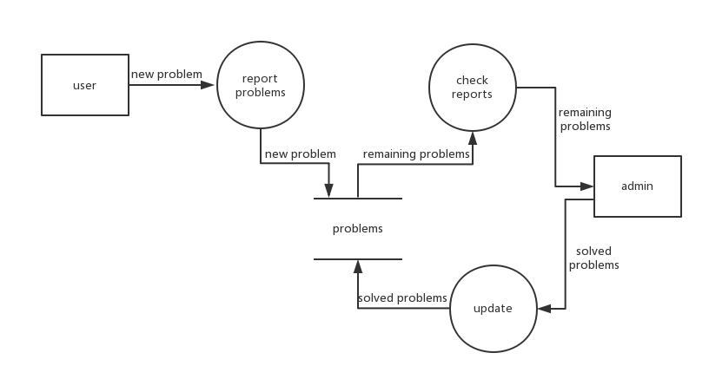

figure 9

**3.3.8 Release Official News** (figure 10)

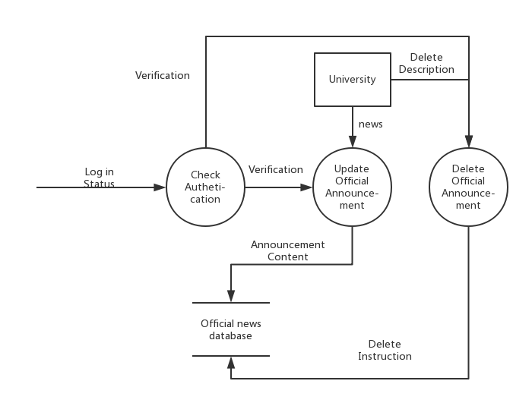

figure 10

**4. System Architecture**

**4.1 Architecture Diagram** (figure 11)

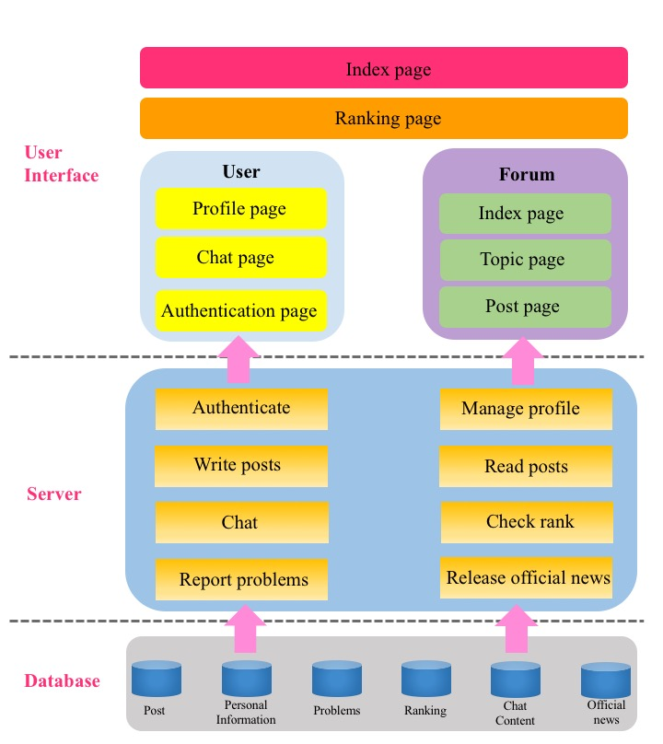

figure 11

**4.2 System Components**

**4.2.1 Front-end Components**

**4.2.1.1 User pages**

(a) Profile page

The profile page is a personalized page which is composed of personal information, friend lists, posts and so on.

(b) Chat page

Users can send messages to friends by typing in the lower dialog box and clicking send button. The messages are displayed in the upper dialog box.

(c) Authentication page

Users can sign up, log in and log out in this page.

**4.2.1.2 Forum pages**

(a) Front page

It is the homepage of universities. There is an index box on the left which lists different topics related to the university. The right side shows the official announcement and hot posts. Users could browse posts widely to have a holistic know about the university or find posts according to topics straightly to get the information that they search for.

(b) Topic page

The posts of the topic are listed in this page on the basis of the number of ‘Like’ or update time. Users could browse the title of the posts and choose the useful ones. Or users could post their own experience in that topic.

(c) Post page

The posts in detail are shown in the page. Users could ‘Like’ the post, save the post, make a comment, go back to the previous page or continue to the next page.

**4.2.1.3 Ranking page**

This page displays the ranking of universities. The rankings include QS World University Rankings, Times Higher Education World University Rankings and Academic Ranking of World Universities. Our ranking page also supports ranking by subject and country.

**4.2.2 Back-end Components**

**(a) Authenticate**

Authentication is basically checking users’ inputs according to the corresponding reserved entry in the personal information database.

**(b) Manage profile**

Personal information management can be decomposed into several sub-functions. Entering personal front page requires the log-in status from the authentication step. Changing personal information enables the to modify his/her profile, like user name, photo and so on. Changing the password allows the user to replace the old password with a new one. Manage relationship enables the user to add, delete new friends or follow and unfollow someone. Checking post history enables the user to check and edit all the post he/she once posted or commented on. Checking marked post enables the user to revisit the the post he/she once marked. Locking enables user to lock up some part of the personal profile for privacy.

**(c) Write posts**

If having logged in, the user or university could create new a post, add labels or comment. All the information would be stored in post data base.

**(d) Read posts**

The viewer (user or university) could view the post list by default or by preferred setting like view by time, view by popularity and so on. Upon clicking on a certain post, its content would be shown to the viewer.

**(e) Chat**

Having logged in, the user could open a chat box, send and receive message with another user. User can also delete the chat history.

**(f) Check rank**

The user could see the rankings of universities from the ranking page by default or by preferred setting like view by majors, view by publishers and so on. He/she can also search the university and see its ranking. The Admin could edit and update the rankings.

**(g) Report problems**

The user could report new problems to the system and admin could get the message from the problems database. After tackling the problem, the database will be manually updated.

**(h) Release official news**

Having logged in, the university user could update or delete the official announcement, which will be stored in official news database.

**4.3 Description of system major components by UML**

**4.3.1 Class diagram** (figure 12)

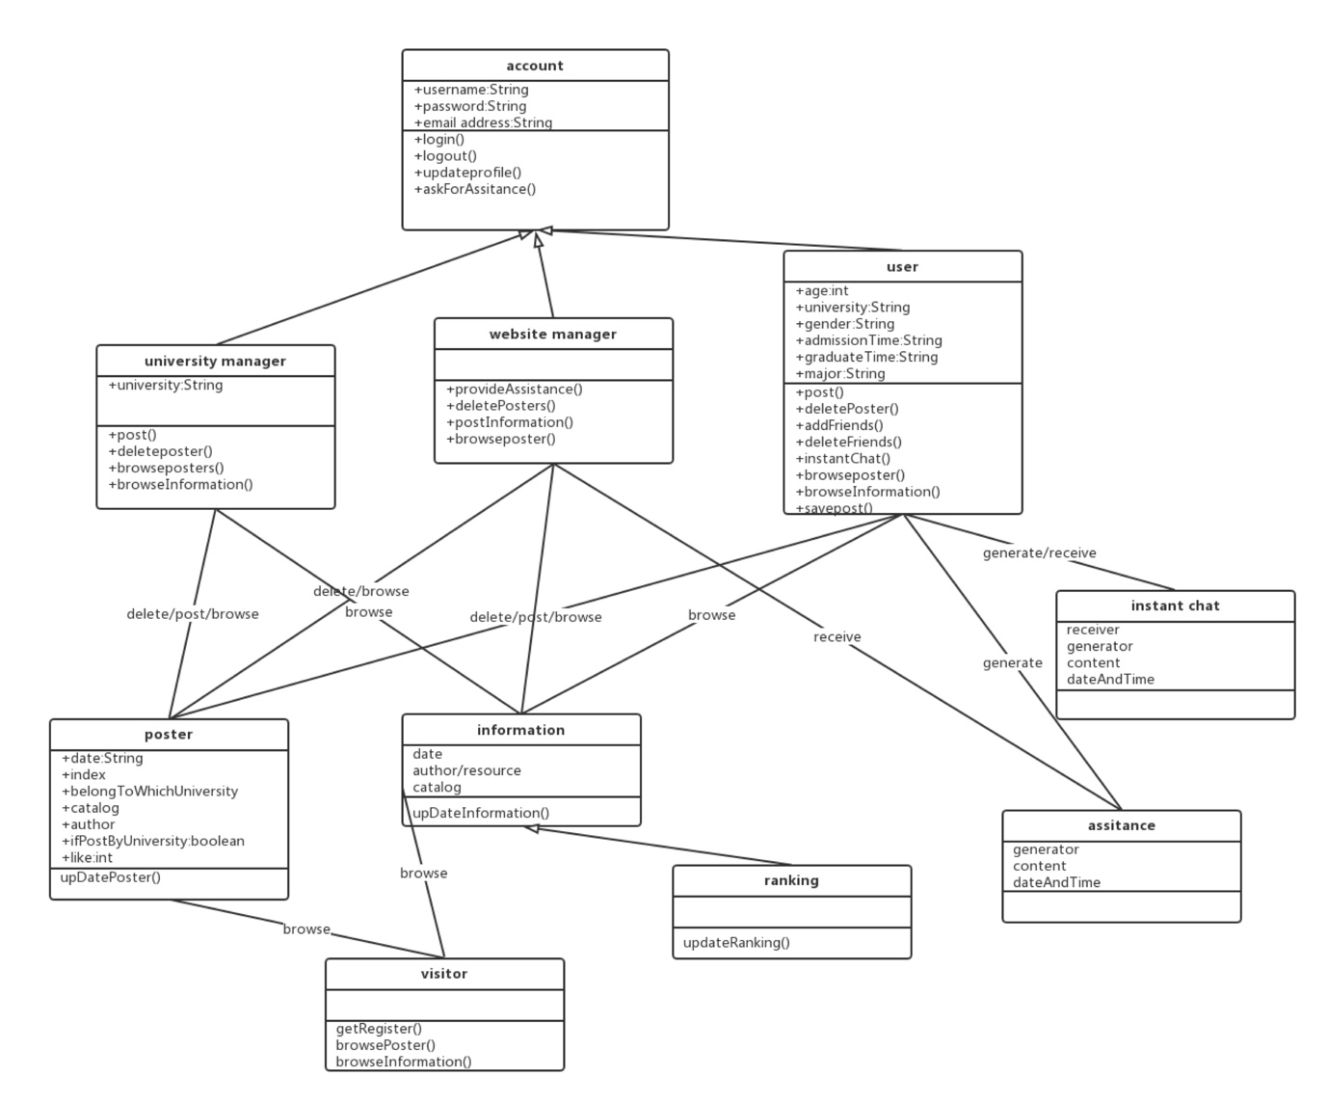

figure 12

**4.3.2 Case diagram** (figure 13)

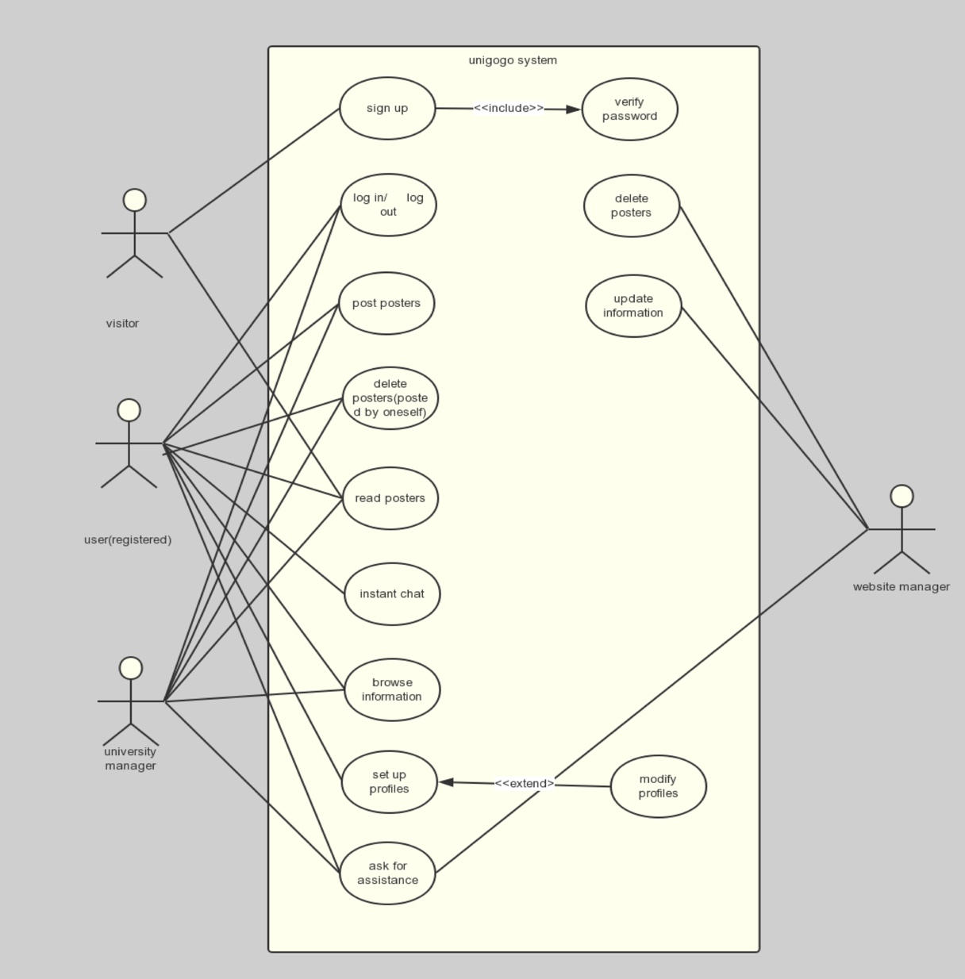

figure 13

**4.3.3 Sequence diagram** (figure 14)

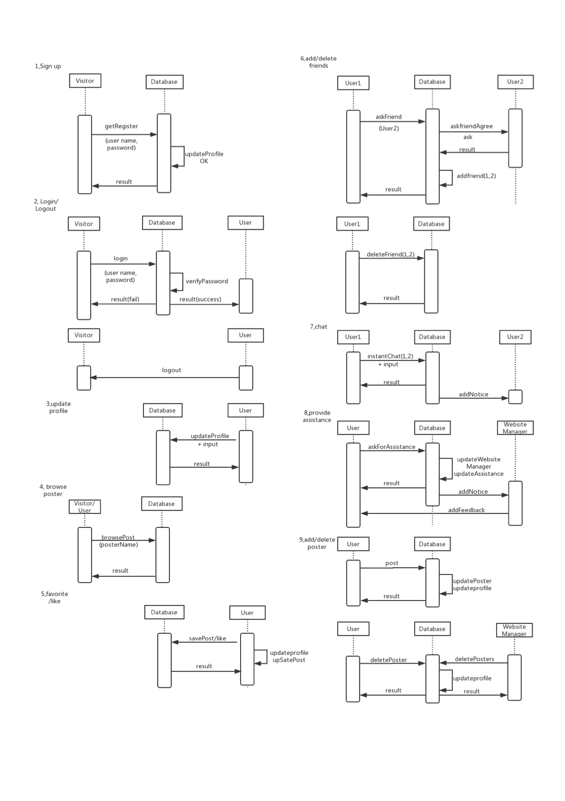

figure 14